ST ANDREWS UNIVERSITY MOUNTAINEERING CLUB
est. 1934
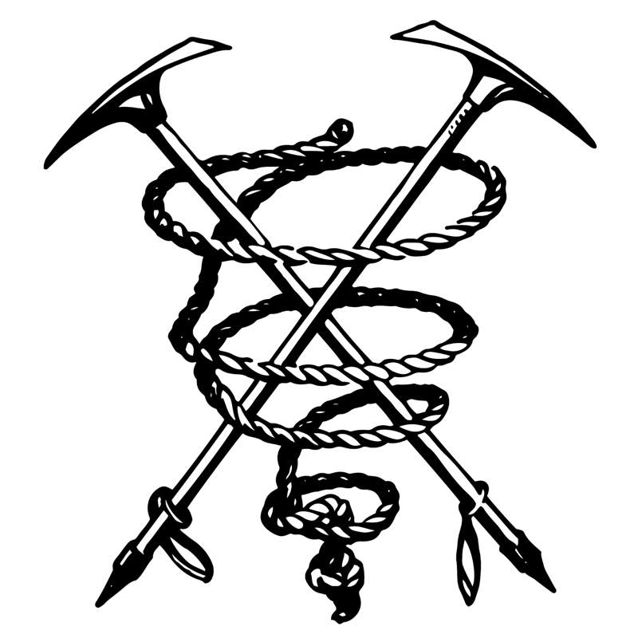

as affiliated with the Athletic Union, University of St Andrews.

4

SAFETY POLICIES AND PROCEDURES 2020/21

National Governing Body Affiliation

The St Andrews University Mountaineering Club (STAUMC) is affiliated with Mountaineering Scotland (MS).

National Governing Body Safety Codes

The club will accept and follow the codes of practice set down by Mountaineering Scotland and the British Mountaineering Council.

Roles and Responsibilities for Safety of Club Members

Members of the club are not instructors, and there is no demand for them to have any formal qualifications.

As such no club member shall ‘lead’ or be ‘led’ but rather may only accompany or be accompanied by other members of the club.

All activities organised by STAUMC should be undertaken in the spirit of imparting accumulated knowledge (peer to peer) rather than a teacher/learning environment unless otherwise stated and arranged by an external body.

Where possible, group sizes should be limited to a maximum of seven when walking or un-aided scrambling and to a maximum of three when climbing or scrambling with the intention of using a rope.

It is stressed that each member who takes part in any club activity must be able and equipped to assume full responsibility for his or her actions.

It is recognised that the safety of a less experienced members may benefit from the presence of more experienced members, and such combinations are to be encouraged.

Where possible, group sizes should be limited to a maximum of seven when walking or un-aided scrambling and to a maximum of three when climbing or scrambling with the intention of using a rope.

The club are committed to providing training opportunities to members to increase their knowledge, skills and competency, and encouraging participation in this. This is done primarily through the SMART Student weekend, the Student Winter Skills weekend, the Student Winter Climbing weekend, use of the St John Scotland Mountain Safety Instructor, suitably qualified instructors and guides employed by the club on an ad-hoc basis and subsidising, where possible, Mountain Training Association courses.

For an up to date list of qualifications and training courses completed by club members, contact the Safety Officer.

Codes of Practice 5

It is the aim of the club to promote enjoyment of the mountains and a responsible attitude
towards mountaineering. The Club recognises and endorses Mountaineering Scotland’s Participation Statement:

Mountaineering Scotland recognises that climbing and mountaineering are activities with a danger of personal injury or death. Participants in these activities should be aware of and accept these risks and be responsible for their own actions and involvement.

Every member attending indoor climbing wall sessions or outdoor meets should be aware that climbing and mountaineering are high risk activities. Members of the club can only give advice to others on a peer to peer basis.

Every member of the party takes personal responsibility to be suitably equipped and physically able to participate in all activities. Advice on a suitable condition-appropriate kit-list will be delivered in advance of every trip.

When a party is to undertake climbs of any nature (rock, ice or mixed) it is solely their responsibility to ensure that adequate equipment for the conditions and intended route are taken and all members of the party should be both confident and competent using the necessary equipment.

The Gear Officer will be responsible for the lending and maintenance of club equipment and will endeavour to ensure all equipment is of a suitable standard prior to be used. However, all equipment checks are performed on the basis of an unqualified assessment and members must perform their own checks and take responsibility for use of all equipment.

A log book is to be carried on every club meet and before beginning any activity each member must sign this book, giving his or her full names, a brief description of his or her proposed route and estimated return time. As far as is reasonable, this route should be adhered to.

On their return all members must sign in. It is the collective responsibility of all trip participants to ensure this is done properly.

In the event that members have not returned at their stated time, the overdue policy (see below) will be followed.

The club will seek the appropriate insurance from Mountaineering Scotland to cover its active members and make members aware of the insurance cover provided. Members are responsible for ensuring that they are satisfied with the cover provided.

Any members responsible for driving Athletic Union hired transportation must have passed the AU Driving test, been given the necessary safety briefings and will adhere to the guidelines placed on the AU website.

Any members driving their own transportation for the purpose of club meets take responsibility for the state of their vehicle and ensuring that they are competent to drive it.

7
8) Risk Assessment

Weather
Hazard (Rate) | Risks | Controls
General |  | Members should ensure that they are aware of all the potential hazards before setting off and ensure that they have the correct equipment, know how to use it, and are able to take steps to mitigate the conditions. Make conservative decisions and if in doubt, do not do it.
Thick mist or cloud (high) | Getting lost. | Carry map/compass and practice good navigation.  Fill in log book as outlined in overdue procedure (see below).  Carry a GPS device to use to re-locate when lost. It is noted that use of electronic navigation aids are not to be solely relied upon, but rather compliment use of a paper map and compass.  Watch and be aware of weather changes; check forecasts and have an escape route planned.
Rain (high) | - Wet and cold.  - Rivers in spate. | - Good waterproof clothing and carry warm spare clothing in a dry bag.  - Make conservative decisions: Only proceed with a river crossing once all other options (for instance, finding an alternate route) have been exhausted. If necessary, wait until river flow has lessened.
Snow (high) | - Cold, wet, hypothermia, frostbite, exhaustion.  - Increased time to complete route.  - Snow blindness and sunburn. | - Aware that rain in valley can mean blizzard on mountaintops.  Have warm clothing, hypothermic blanket or sleeping bag.  Build a basic snow shelter.  - Maintain contact with other members on the trip to keep  them updated of progress if you expect to be overdue.  Careful route planning and carry a headtorch and extra food.  - Goggles and sunblock.  Seek professional medical advice as soon as possible.
Wind (high) | - Exhaustion, wind-chill, hypothermia.  - Blown over on mountain or fall off ridge/cliff. | - Warm clothing and wind- proofs including hat and gloves.  Carry a group shelter.  - Choose appropriate route and be prepared to alter plans  When appropriate, link arms with another person and give  each other support or consider the use of a rope.
Cold (high) | Hypothermia, frostbite,  exhaustion. | Warm clothing, emergency  shelter, food and drink.
Electric storm (low) | Lightning strike, burns, shock or death. | Watch and be aware of weather changes; check forecasts.  If caught out on the hill, sit on dry rope or rucksack; on a cliff, sit out storm on ledge, avoiding chimneys and wet ropes.
Heat (low) | Sunburn and dehydration, leading to decrease in physical and mental efficiency. | Carry and drink plenty of water; wear a sun hat and sun block.

Hill Walking
Hazard (Rate) | Risks | Controls
General |  | Members should ensure that they are aware of all the potential hazards before setting off and ensure that they have the correct equipment, know how to use it, and are able to take steps to mitigate the conditions. Make conservative decisions and if in doubt, do not do it.
Falling or slipping (medium) | Grazes, bruising, muscular injury, broken bones, shock, knocked unconscious, hypothermia. | Route choice takes into account difficulty of terrain; check surroundings.  Observe other group members and alter plans if necessary.  Wear appropriate footwear.  Carry appropriate personal first aid equipment.
Getting lost (medium) | May lead to darkness, hunger, thirst, benightment, exposure, exhaustion or hypothermia. | As due to thick mist, white out, etc check weather report before hand and practice good navigation.  Carry GPS device as a back-up
Losing a group member (low) | All the above. | Tell group members to stay together and what action to take place if separated. All group members to be properly  equipped.
Cold and Heat (medium) | (See Weather) | (See Weather)
Falling rocks (low) | Head injury, knocked over, unconscious. | Wear a helmet where necessary.  Be cautious when below other climbers. Never throw anything; a falling rock should be accompanied by a call of ‘below’.
Caught in an avalanche (medium-high) | Suffocation, cold, hypothermia, injury. | Monitor prevailing weather conditions and avalanche forecasts for the relevant area in the days leading up to activity.  Continually monitor conditions in the area, performing dynamic risk assessment through testing snow by digging snow pit and examining binding. Risk can be reduced by keeping to ridges, flat and wind scoured areas.  Ensure avalanche transceivers are fully charged before setting out.  Practice avalanche rescue scenarios regularly.  If someone is caught in an avalanche then note/mark the last place the victim was seen and initiate a search immediately.  The use of avalanche transceivers or other avalanche safety equipment such as airbags should not impact decision making in any way: It does not permit the crossing of a slopes considered to be a serious avalanche risk.
Stuck in a bog (low) | All the above. | Walk in groups; avoid particularly boggy areas by walking around.
Darkness (medium) | See getting lost. | Carry a head torch.
Losing a rucksack (low) | See getting lost. | Good organisation; be aware of exposed positions; walk in groups.
Water hazard (medium) | Drowning, cold, hypothermia. | Choose appropriate route.
Attacked by or bitten by birds and animals (low) | Injury. | Carry personal 1st aid kit; avoid nesting sites.
Mugged when walking or hitching (low) | Injury, shock, etc. | Walk in groups.
Hit by car or bike (low) | Injury. | Carry personal 1st aid kit; observe highway code.

11

Rock Climbing
Hazard (Rate) | Risks | Controls
General |  | Members should ensure that they are aware of all the potential hazards before setting off and ensure that they have the correct equipment, know how to use it, and are able to take steps to mitigate the conditions. Make conservative decisions and if in doubt, do not do it.
Equipment failure (low) | Any injury due to fall. | Use equipment only for the purposes for which it was designed.  Follow guidelines for care, recommended lifetime and disposal of equipment.  Where possible, gear officer to keep careful note of equipment’s history.  Always check your own and others gear before and after use.
Fall while abseiling (low) | Any injury due to fall. | Ensure an appropriate anchor is used to abseil from.  Back up your abseil device with a prussik know.  Tie a suitable knot in the end of abseiling rope(s) to prevent abseiling off the end of the rope.
Falling rocks (medium) | See above (Hill Walking) | See above (Hill Walking)
Falling in sea (low) | Drowning. | Ensure climbers stay on a suitably anchored rope or well away from cliff edges.
Harness not holding a fall (low) | Any injury due to fall. | Harness should be properly fastened. Tie in with a suitable knot.  Always check partners have tied in and secured their harness properly.
Confusion during climbing calls (medium) | Unexpected fall/ premature removal of belay. | Climbing calls should be agreed upon before starting a climb.  Alternatives such as tugging the rope should be agreed.
Fall due to poor belay (low) | Any injury due to fall. | Belay to secure points. The system should be set to avoid shock loading if one piece of protection should fail. Place a piece of protection to protect the belay from shock loading in case of a factor two fall.  Running ropes sharp edges can damage them. Use of a rope protector should be considered when setting ‘bottom rope’ systems to mitigate this.
Fall due to poor belay technique (low) | Any injury due to fall. | Use suitable belay method and always keep at least one hand on the dead rope, holding it in the locked off position.  When belaying, position yourself in such a way that you would not be dislodged in the  event of a fall.
Fall when bouldering (medium) | Any injury due to fall, plus injury to bystanders. | Always work in conjunction with an able spotter, ensure that you do not boulder above the ‘shelves’ or near other climbers.  Use an appropriate bouldering pad(s).
Injury to belayer (low) | Trapped hair/ fingers/ clothing etc. | Ensure proper technique is used.  Tie long hair back  Don’t wear loose clothing (e.g. scarves)
Fall and protection not holding (moderate) | Any injury due to fall. | Ensure protection is properly placed. Consider likely direction of pull in the case of a fall. If in doubt, don’t rely solely upon it.
Fall near crag when untied (low) | Any injury due to fall. | Take extra care when untied. Only untie once well away from cliff edges.  Always wear suitable footwear and helmet.  Be aware of the terrain and difficulty before continuing (e.g. grass, wet or loose rock). Know and use recommended descent routes before starting.

Winter Climbing
Hazard (Rate) | Risks | Controls
General |  | Members should ensure that they are aware of all the potential hazards before setting off and ensure that they have the correct equipment, know how to use it, and are able to take steps to mitigate the conditions. Make conservative decisions and if in doubt, do not do it.
Equipment failure (low) | See above (Rock Climbing). | See above (Rock Climbing).
Falling rocks (medium) | See above (Rock Climbing). | See above (Rock Climbing).
Harness not holding a fall | See above (Rock Climbing). | See above (Rock Climbing).
Confusion during climbing calls | See above (Rock Climbing). | See above (Rock Climbing).
Fall due to poor belay | See above (Rock Climbing). | See above (Rock Climbing).
Fall due to poor belay technique (low) | See above (Rock Climbing). | See above (Rock Climbing).
Fall when abseiling (low) | See above (Rock Climbing). | See above (Rock Climbing).
Fall and protection not holding (medium) | See above (Rock Climbing). | See above (Rock Climbing).
Fall near crag when untied (low) | See above (Rock Climbing). | See above (Rock Climbing).
Caught in an avalanche (medium) | See above (Hill Walking). | See above (Hill Walking).
Hypothermia, frost bite, heat aches (high) | See above (Hill Walking- cold)  Hands are particularly susceptible. | See above (Hill Walking- cold)  Wear warm waterproof gloves and warm clothes to maintain core temperature.  Carry spare pairs of gloves and extra layers (e.g. duvet jacket) in rucksack.
Collapse of ice (medium) | Any injury due to fall. | Check condition of the ice before climbing.
Lead fall onto belayer (low) | Injury due to sharp points. | Belayer should carefully watch the climber be prepared to move if necessary, climber maintain communication with the belayer.
13
Ski Touring/Mountaineering
Hazard (Rate) | Risks | Controls
General |  | Members should ensure that they are aware of all the potential hazards before setting off and ensure that they have the correct equipment, know how to use it, and are able to take steps to mitigate the conditions. Make conservative decisions and if in doubt, do not do it.
Thick mist or cloud (high) | See above (Hill Walking) | See above (Hill Walking)
Getting Lost (medium) | See above (Hill Walking) | See above (Hill Walking)
Losing a group member (low) | See above (Hill Walking) | See above (Hill Walking)
Falling rocks (low) | See above (Hill Walking) | See above (Hill Walking)
Equipment Failure (Moderate) | Binding fails to release | Participants should check their bindings, appropriately set their DIN and regularly do a physical binding release test before setting out.  Participants should carry winter hillwalking equipment in case of total ski equipment failure.
Avalanche (Moderate) | See above (Hill Walking) | See above (Hill Walking)
Falling Over/ Collisions (High) | Injury | All descents should be within the ability of all members of the group, especially in difficult snow conditions- conservative decisions should be made.  Participants should wear a helmet while making ski descents and other protection (e.g. a back protector) at their discretion.
Snow (high) | See above (Weather) | See above (Weather)
Cold (high) | See above (Weather) | See above (Weather)
14

Indoor Climbing
Hazard (rate) | Risks | Controls
General |  | Members should ensure that they are aware of all the potential hazards before setting off and ensure that they have the correct equipment, know how to use it, and are able to take steps to mitigate the conditions. Make conservative decisions and if in doubt, do not do it.
Falling onto the rope (high) | Any injury due to fall against wall pannels/holds etc. | Ensure proper belaying techniques, attentive belaying and spotting.  Climbers should be aware of obstructons near their route.
Equipment failure (low) | See Above (Rock Climbing) | See Above (Rock Climbing)
Harness not holding a fall (low) | See Above (Rock Climbing) | See Above (Rock Climbing)
Fall due to poor belay technique (medium) | See Above (Rock Climbing) | See Above (Rock Climbing)
Fall when bouldering (medium) | See Above (Rock Climbing) | See Above (Rock Climbing)
Injury to belayer | See Above (Rock Climbing) | See Above (Rock Climbing)
Dropped items | Injury to belayers and bystanders | Climbers should not take unecessary items up the wall.  Belayers and bystanders should stand away from the base of the wall when routes are being climbed.
15
16

Transport on Club Meets
Hazard (rate) | Risks | Controls
Road Traffic Accident | Any level of injury, including death. | Drivers shall adhere to the highway code, and seatbelts shall be worn.  Any private vehicle used on club meets is the owners responsibility, and the owner is responsible for ensuring that it is in a roadworthy and legal condition.  All drivers shall take note of current AU code of practice for drivers.
Breakdown | Delay, stranding club members. | Drivers of AU transport shall carry out routine checks before departing, drivers of their own vehicles are responsible for their  upkeep/recovery.
Lost | Delay, stranding club members. | Drivers should take due consideration of the route, and use a map or SatNav system for guidance
Other
Hazard (Rate) | Risk | Controls
Tent on fire (low) | Burns, smoke inhalation. | Cook outside.  Pitch tents no closer than 10 meters apart.
Bothy on fire (low) | Burns, smoke inhalation. | Take care when cooking, using gas lighting, candles and open fireplaces.  Ensure open fires and gas stoves are well ventilated to prevent carbon monoxide poisoning.
Hut bothy stove (low) | Burns. | Keep 1st aid kit accessible at all times, do not overfill bothy, do not cook when drunk.
Traffic accident (High) | Injury/death. | Climbers should take care on roads, particularly at night, and should consider wearing a head torch.

17

Emergency Procedures

Overdue Procedure:

- As outlined above, all parties on club activities will fill in some form of log, detailing their plans and expected time of return.
- In the event that you suspect you/ your party will be overdue:
- Inform another club member attending the trip (outwith your party) that you suspect you will be overdue, your current location, the time message is being sent, an updated estimated return time and next steps (e.g. changing route or abandoning objectives) by text or phone as soon as possible.
- Remain in contact with, and continue to update, this individual until you/ your party are off the hill.
- In the event that a party is overdue:
a) At least two club members, including one driver, will remain sober until all parties have returned
b) Attempts will repeatedly be made to make phone contact with the overdue party. No attempts will be made to physically find or rescue the overdue party: This is to ensure the safety of other members.
c) If contact is made with an overdue party, or a party that suspects they will be overdue, the time contact was made, their current location, updated plans and updated estimated return time should be recorded.
d) If no contact has been made with the overdue party after two hours from their estimated (or updated estimated) return time, the police will be informed (in the UK, the police coordinate mountain rescue) and take responsibility for the missing person(s).

In the event of an accident/near miss:

- Members should first ensure their own safety to prevent further accidents.
- If necessary, the emergency services should be contacted directly then other club members on the meet
- Members involved should fill in either an incident or near miss form (these are available on request from the Safety Officer)
- The Athletic Union should also be contacted and on return the Safety Officer shall be responsible for filling in the accident report forms.

First Aid Kits

Club members shall be responsible for providing their own personal first aid kit (the contents of which will vary depending on conditions etc.), Items shall be replaced immediately upon use.

